What kinds of study limitations exist?
There are several reasons why study limitations might exist. But two main categories of limitations are those that result from the methodology and those that result from issues with the researcher(s).

Common Methodological Limitations
Limitations due to methodological problems can be addressed by clearly and directly identifying the potential problem and suggesting ways in which this could have been addressed—and SHOULD be addressed in future studies. The following are some major potential methodological issues that can impact the conclusions researchers can draw from the research:

Issues with sample and selection
Sampling errors occur when a probability sampling method is used to select a sample, but that sample does not reflect the general population or appropriate population concerned. This results in limitations for your study known as “sample bias” or “selection bias.” For example, if you conducted a survey to obtain your research results, your samples (participants) were asked to respond to the survey questions. However, you might have had limited ability to gain access to the appropriate type or geographic scope of participants. In this case, the people who responded to your survey questions may not truly be a random sample.

Insufficient sample size for statistical measurement
When conducting a study, it is important to have a sufficient sample size in order to conclude a valid research result. The larger the sample, the more precise your results will be. If your sample size is too small, it will be difficult to identify significant relationships from the data.
Normally, statistical tests require a larger sample size to ensure that the sample is considered representative of a population and that the statistical result can be generalized to a larger population. It is a good idea to understand how to choose an appropriate sample size before you conduct your research by using scientific calculation tools.

Lack of previous research studies on the topic
Citing and referencing prior research studies constitutes the basis of the literature review for your thesis or study, and these prior studies provide the theoretical foundations for the research question you are investigating. However, depending on the scope of your research topic, prior research studies that are relevant to your thesis might be limited.
When there is very little or no prior research on a specific topic, you may need to develop an entirely new research typology. In this case, discovering a limitation can be considered an important opportunity to identify new gaps in the prior literature and to present the need for further development in the area of study.
- Methods/instruments/techniques used to collect the data
After you complete your analysis of the research findings (in the Discussion section), you might realize that the manner in which you have collected the data or the ways in which you have measured variables has limited your ability to conduct a thorough analysis of the results. For example, you might realize that you should have addressed your survey questions from another viable perspective, or that you were not able to include an important question in the survey. In these cases, you should acknowledge the deficiency or deficiencies by stating a need for future researchers to revise their specific methods for collecting data that includes these missing elements.
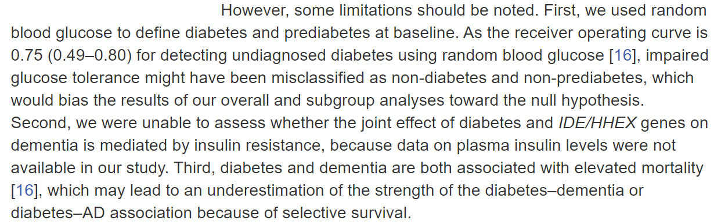
This limitations section addresses the potential issues caused by the study’s methodology.

Common Limitations of the Researcher(s)
Limitations that arise from situations relating to the researcher or researchers (whether the direct fault of the individuals or not) should also be addressed and dealt with, and remedies to decrease these limitations–both hypothetically in your study and in future studies–should be proposed.

Limited access to data
If your research involved surveying certain people or organizations, you might have faced the problem of having limited access to these respondents. Due to this limited access, you might need to redesign or restructure your research in a different way. In this case, explain the reasons for limited access and be sure that your finding is still reliable and validate despite this limitation.

Time constraints
Just as students have deadlines to turn in their class papers, academic researchers also must meet the deadline for submitting a research manuscript to a journal. Therefore, the time available to study a research problem and to measure change over time is constrained by the deadline of your “assignment.” Make sure you choose a research problem that you will be able to complete well before the assignment’s deadline. If time constraints negatively impacted your study in any way, acknowledge this impact by mentioning a need for a future study (e.g., a longitudinal study) to answer this research problem.

Conflicts arising from cultural bias and other personal issues
Researchers might be biased views due to their cultural backgrounds or perspectives of certain phenomena, and this can affect a study’s legitimacy. Also, it is possible that researchers will have biases toward data and results that only support their hypotheses or arguments. In order to avoid these problems, the author(s) of a study should examine whether the way the problem was stated and the data-gathering process were carried out appropriately.

Steps for Organizing Your Discussion of Limitations
When you discuss study limitations, don’t simply list and describe your limitations–explain how these limitations have influenced your research findings. There might be multiple limitations in your study, but you only need to point out and explain those that directly relate to and impact how you address your research questions.
We suggest that you divide your limitations section into three steps: (1) identify the limitations; (2) explain how they impact your study; and (3) propose a direction for future studies and present alternatives. By following this sequence when discussing your study’s limitations, you will be able to clearly demonstrate your study’s weakness without undermining the quality and integrity of your research.

Common Phrases Used to Discuss Study Limitations
The following phrases are frequently used to introduce and describe study limitations:

“There may be some possible limitations in this study.”

“The findings of this study have to be seen in light of some limitations.”

“The first is the…The second limitation concerns the…”

“The empirical results reported herein should be considered in the light of some limitations.”

“This research, however, is subject to several limitations.”

“The primary limitation to the generalization of these results is…”

“Nonetheless, these results must be interpreted with caution and a number of limitations should be borne in mind.”

“As with the majority of studies, the design of the current study is subject to limitations.”

“There are two major limitations in this study that could be addressed in future research. First, the study focused on …. Second ….”

