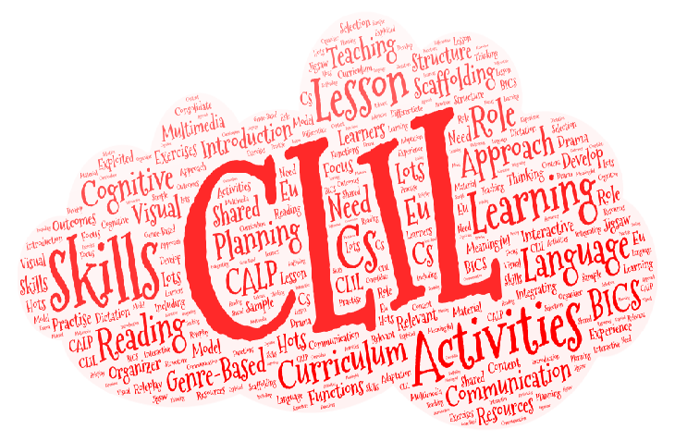

I want to learn how to…

I want to know about…

**What do you want to know, learn, or develop in relation to CLIL?**

**What do you know about CLIL?**