Questions | name | name | name | name
What is the first thing that attracts you to someone?
Do you believe in love at first sight? Why or why not?

Have you ever had a crush on someone you didn’t really know well? What did you do?

Have you ever been in a relationship that had one-sided love?
Have you ever known someone was interested in you, but you really weren’t interested in them? What did you do?
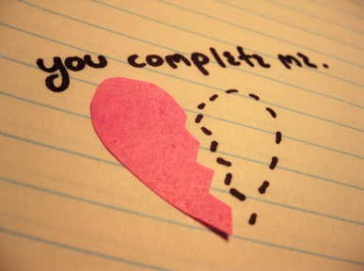
One-Sided Love
Survey 4 people

