Questions | name | name | name | name
What are the most attractive qualities you think a person can have?
What qualities are most important for a romantic relationship? Why?

What are some habits people have that annoy you?
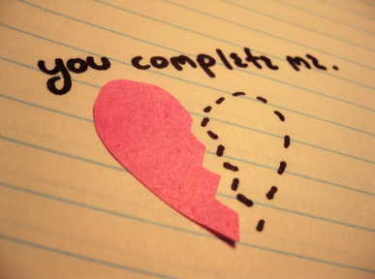
Relationships
Survey 4 people

