Questions | Name | Name | Name | Name
Have you ever been abroad?
What was your best trip in Korea or abroad? Why?

Do you prefer to travel by train, bus, plane or ship? Why?

What country do you most want to visit? Why?
What countries would you not like to visit? Why?
Do you enjoy travelling with your parents? Why or why not?
When looking for a hotel to stay in what is the most important thing for you? Price? Location? Cleanliness? Other?
Would you prefer to travel to a hot country or a cool country? Why?
Would you prefer to have a relaxing vacation on the beach or a busy vacation visiting many attractions? Why?

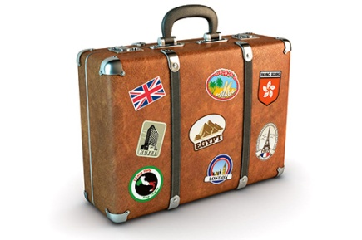
Travel and Tourism
Survey 4 people!

