(M.A. 2021)

A Case Study of Korean Secondary EFL Learners’ Student-generated Reading Comprehension Test Development as Learning-oriented Assessment

by
Gi Jung Kim

DEPARTMENT OF ENGLISH LANGUAGE TEACHING
GRADUATE SCHOOL OF TESOL
HANKUK UNIVERSITY OF FOREIGN STUDIES
A Case Study of Korean Secondary EFL Learners’ Student-generated Reading Comprehension Test Development as Learning-oriented Assessment

by
Gi Jung Kim

Under the Direction
of
Professor Hyun Jung Kim

Thesis submitted to the Graduate School of TESOL of
Hankuk University of Foreign Studies in partial fulfillment of the requirements for the degree of Master of Arts

August 2021
Approved by the Graduate School of TESOL committee of
Hankuk University of Foreign Studies in partial fulfillment
of the requirements for the degree of Master of Arts

Thesis Committee: ____________________ _____________

____________________ _____________

____________________ _____________

DEPARTMENT OF ENGLISH LANGUAGE TEACHING
GRADUATE SCHOOL OF TESOL
HANKUK UNIVERSITY OF FOREIGN STUDIES
ACKNOWLEDGEMENTS

I would like to…

ABSTRACT

A Case Study of Korean Secondary EFL Learners’
Student-generated Reading Comprehension Test Development
as Learning-oriented Assessment

Kim, Gi Jung
Department of ELT, Graduate School of TESOL
Hankuk University of Foreign studies

The purpose of this study…

TABLE OF CONTENTS

ACKNOWLEDGEMENTS i
ABSTRACT ii
TABLE OF CONTENTS iii
LIST OF TABLES viii
LIST OF FIGURES ix

CHAPTER I. INTRODUCTION 1
1.1 Background of the Study 1
1.2 Purpose of the Study 3

CHAPTER II. LITERATURE REVIEW 7
2.1 Classroom-based Assessment (CBA) 7
2.2 Learning-oriented Assessment (LOA) 11
2.2.1 Historical and Conceptual Development of LOA 11
2.2.2 The Working Framework for LOA 15
2.2.3 Empirical Studies on LOA 18
2.3 Classroom-based L2 Reading Assessment in Korea 30

CHAPTER III. METHODOLOGY 33
3.1 Design of the Study 33
3.2 Context of the Study 35
3.3 Participants 37
3.4 Materials 41
3.4.1 Reading Texts 41
3.4.2 Reading Worksheets 43
3.5 Instruction 44
3.5.1 Reading Instruction 44
3.5.2 Student-generated Reading Comprehension Test Development 46
3.6 Instruments 50
3.7 Data Collection Procedures 51
3.8 Data Analysis 54

CHAPTER IV. RESULTS AND DISCUSSION 59
4.1 The Nature of the Student-generated Reading Comprehension Test Development as LOA 59
4.1.1 Students’ Reading Practices Aligned with Learning Goals 61
4.1.2 Students’ Self-evaluation of Their Reading Comprehension 66
4.1.3 Students’ Peer-feedback Exchange to Improve Their Reading Comprehension 71
4.2 Learning in the Main-idea Comprehension through Participation in Group Discussion 82

CHAPTER V. CONCLUSION 90
5.1 Summary of the Results 90
5.2 Pedagogical Implications of the Study 93
5.3 Limitations and Suggestions for Further Research 100

REFERENCES. 102
APPENDICES 112
ABSTRACT IN KOREAN...........................................................................122
TABLE OF CONTENTS

ACKNOWLEDGEMENTS i
ABSTRACT ii
TABLE OF CONTENTS iii
LIST OF TABLES viii
LIST OF FIGURES ix

CHAPTER I. INTRODUCTION 1
1.1 Background of the Study 1
1.2 Purpose of the Study 3

CHAPTER II. LITERATURE REVIEW 13
2.1 Pronunciation Instruction Overview 13
2.1.1 History of Pronunciation Instruction 14
2.1.2 Pronunciation Instruction in South Korea 24
2.1.2.1 Pronunciation Model: The Korean Context 26
2.2 NNES Teachers’ Pronunciation Teaching Difficulties 28
2.2.1 Teacher Hesitancy 28
2.2.2 Learner’s Attitude 30
2.2.3 Lack of Teacher Training 31

CHAPTER III. METHODOLOGY 38
3.1 Research Context 38
3.2 Participants 39
3.3 Data Collection Materials 41
3.3.1 Semi-structured Interview Schedule 41
3.3.2 Open-ended Survey 41
3.4 Data Collection Procedures 42
3.5 Data Analysis 44

CHAPTER IV. FINDINGS 50
4.1 Findings: Research Question 1 50
4.1.1 Teachers’ Difficulties 51
4.1.1.1 Reported Difficulty 1 53
4.1.1.2 Reported Difficulty 2 60
4.1.1.3 Reported Difficulty 3 65
4.2 Findings: Research Question 2 70
4.2.1 Suggestions to Overcome Teaching Difficulties 70
4.2.1.1 Suggestion 1 71
4.2.1.2 Suggestion 2 76
4.2.1.3 Suggestion 3 80

CHAPTER V. DISCUSSION 85
5.1 Discussion of Findings Related to Research Question 1 85
5.2 Discussion of Findings Related to Research Question 2 95

CHAPTER VI. CONCLUSION 110
6.1 Summary of the Results 110
6.2 Pedagogical Implications of the Study 113
6.3 Limitations and Suggestions for Further Research 120

REFERENCES 123
APPENDICES 133
ABSTRACT IN KOREAN...........................................................................140
LIST OF TABLES

Table 1: Information on the Participants 40
Table 2:
Table 3:
Table 4:
Table 5:

LIST OF FIGURES

Figure 1: Framework for Learning-oriented Assessment 15
Figure 2:
Figure 3:
Figure 4:

CHAPTER I
INTRODUCTION

  - Background of the Study
The teacher’s role in assessment has been reconceptualized over time with the development of classroom-based assessment (CBA)…

  - Purpose of the Study
As stated earlier, there is a dearth of research on classroom-based L2 reading assessment in Korean secondary English classes…

CHAPTER II
LITERATURE REVIEW

The current study mainly refers to three existing bodies of research: CBA. LOA, and classroom-based L2 reading assessment. This chapter reviews the previous research findings in the three areas, laying the theoretical foundation for this study.

2.1 Classroom-based assessment (CBA)
Traditionally, large-scale standardized testing has been widely used and recognized by researchers and practitioners, leaving classroom teachers as passive users of ready-to-use tests…

2.2 Learning-oriented assessment (LOA)
2.2.1 Historical and Conceptual Development of LOA
The impact of assessment – particularly CBA – on student learning has been highlighted in second language education as well as in general education…

2.2.2 The Working Framework for LOA
There are several working frameworks of LOA, which summarize its essence and suggest its research directions in the future (e.g., Carless, 2007, 2015; Purpura & Turner, 2015). In Carless’ (2007) framework of LOA, he claimed that LOA aims to bridge the certification purpose (summative assessment or AoL) and the learning purpose (formative assessment or AfL) with a central focus on engineering effective student learning. Based on this purpose, LOA is supported by three principles (see Figure 1)…

Figure 1
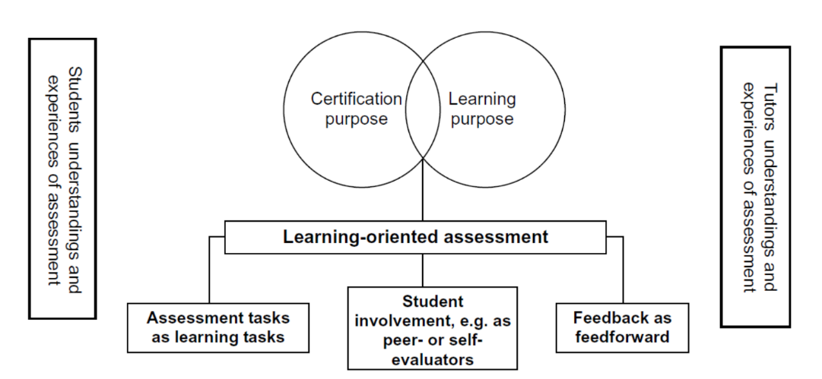
Framework for Learning-oriented Assessment

Note. From “Learning‐oriented Assessment: Conceptual Bases and Practical Implications,” by D. Carless, 2007, Innovations in Education and Teaching International, 44(1), p. 60. Copyright year by name of copyright holder. Reprinted with permission.

2.3 Classroom-based L2 Reading Assessment in Korea
L2 reading is a cognitively complex and unobservable process and thus needs to be appropriately assessed by L2 reading teachers (Brown, 2007)…
CHAPTER III
METHODOLOGY

  - Design of the Study
This study was designed to accomplish two research purposes…

  - Context of the Study
This study was conducted at an international Korean school…

  - Participants
There are two groups of participants in the current study… All the information on the participants is summarized in Table 1…

Table 1
Participant Information
Group | Pseudonym | Gender | Level | Study-abroad Experience
1 | Sun | Male | High | - 7.5 years at the current school
 | Joe | Male | Mid | - 12.5 years including 3.5 years at the current school
 | Kim | Female | Low | - 2.5 years at the current school
2 | Song | Female | High | - 8 years including 3.5 years at the current school
 | Hyun | Female | Mid | - 4 years at the current school
 | Park | Male | Low | - 7 years including 5 years at the current school

REFERENCES

Aliakbari, M., & Haghighi, J. K. (2014). On the effectiveness of differentiated instruction in the enhancement of Iranian learners reading comprehension in separate gender education. Procedia-Social and Behavioral Sciences, 98, 182-189.
American Council on the Teaching of Foreign Languages. ACTFL Proficiency Guidelines 2012. ACTFL. https://www.actfl.org/resources/actfl-proficiency-guidelines-2012/english/reading
Baleghizadeh, S., & Zarghami, Z. (2015). Assessment for learning: The impact of student-generated tests and conferencing on EFL students’ grammar learning. The European Journal of Applied Linguistics and TEFL, 4(1), 45-65.
Brown, H. D. (2007). Teaching by principles: An interactive approach to language pedagogy (3rd ed.). Addison Wesley Longman.
……
Appendix A
Reading Worksheets

Tree Version
Directions: Find and highlight the verbs in each sentence and identify the main verb(s) in a different color. Then, translate the sentences into Korean.
Food / is / one of the basic necessities of life.
_______은 삶의 ______ ____________ 중 하나이다.
Finding, growing, preserving, storing, trading, and eating it / have driven / the course of human history.
_______을 ______하고, ______하고, ______하고, ______하고, _____하고 그리고 ______ 것은 인류 _____의 과정을 ______해 왔다.
The need to eat and the desire to eat something pleasant / have encouraged / meetings of cultures / and exchanges of ideas.
먹을 ________과 기분을 ______ 해 주는 무언가를 먹고 싶은 _____은 _____ 간의 만남과 아이디어 _______을 장려해 왔다.
Looking into the tasty history of food / will allow / us / to better understand / [how / food / has shaped / the world and our history].

Appendix B
Student-generated Reading Comprehension Test Format

(The original format in Korean)
- 본문 중 1~2 문단을 선택하여 다음 지시사항에 따라 문항을 제작하시오.
지문
문항 | ☞ 아래 문항 중 하나를 고르고 나머지는 지우시오.  - 윗글의 주제로 가장 적절한 것은?  - 윗글의 제목으로 가장 적절한 것은?  - 윗글의 교훈으로 가장 적절한 것은?  - 다음 글의 내용을 한 문장으로 요약하고자 한다. 빈칸 (A), (B)에 들어갈 말로 가장 적절한 것은?
보기 | ①  ②  ③  ④  ⑤
정답 및  해설 | ☞ 글의 내용을 요약하면서 정답인 이유를 설명하시오. (오답인 이유 설명 불필요)

국문초록

한국 고등학생 EFL 학습자의 배움중심평가로서의
학생 제작 독해 시험 개발에 관한 사례 연구

김기중
TESOL대학원 ELT학과
한국외국어대학교

본 연구는…

