Names
From 1-10 how happy are you right now? Explain.

What is the happiest memory in your life?

What is one thing that makes you really happy? Why?

What is one thing that makes you unhappy? Why?

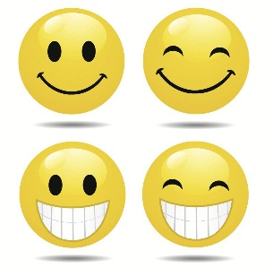
Happiness
Discuss with 4 people

