Questions | Name | Name | Name | Name
Do you enjoy shopping?
Do you prefer to use cash or a card when shopping? Why?
What do you enjoy shopping for?
What do you not enjoy shopping for?
Do you mostly shop online or in person?
What is your favorite store to buy clothes at?
What kind of shopper are you?
What do you spend the most money on these days?
What is the most expensive thing you have ever bought?
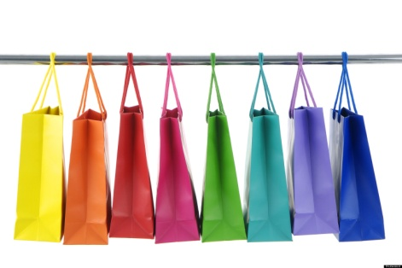
Spending Money
Survey 4 people!

