REFERENCE LETTER

To whom it may concern,

It is my pleasure to write a reference letter for Ms. Sohee Park, whom I have known since September 2017 in my capacity as Assistant Professor at Hankuk University of Foreign Studies. During her M.A. studies, Ms. Park has been a student of mine in the following courses: Teacher Education, Research Methods, and, ELT material development. Through Ms. Park’s hard work in each of these classes she was awarded an A+ in Teacher Education, A+ in Research Methods, and A+ in ELT material development. During her participation in these courses, she has clearly displayed the skills, knowledge, and abilities to excel in the field as both an English teacher and materials developer.

On a personal level, Sohee is a bright and active individual with an infectiously positive personality. She is self-directed, works well with others, and is fun to be around. She has both passion and personal drive which are both important personal assets that will make her invaluable to her future workplace and those that have the opportunity to work with her.

Overall, Sohee has a strong educational, and experiential base in the field to draw from and in my assessment is a perfect fit for the materials developer position she is applying for. I am certain that Ms. Park will continue her high standards of work in all endeavors. It is with the highest level of confidence that I am able to recommend her without hesitation. If there is anything you would like to discuss further, please feel free to contact me by phone or email at any time.

Issued on the 22nd of October 2025.

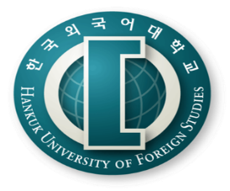
George E.K. Whitehead
Visiting Professor
Graduate School of TESOL
prof.gwhitehead@gmail.com
+82) 10-9800-7817
Faculty Head
Office of the Foreign Faculty

Faculty Head
Office of the Foreign Faculty

Seoul Campus
107, Imun-ro, Dongdaemun-gu,
Seoul, 02450

