What school did you go to?
What did you like about your school?
What did you dislike about your school?
Who was your favorite teacher? Why?
Who was your least favorite teacher? Why?
What was your favorite subject? Why?
What was your least favorite subject? Why?
What was your best memory?
What was your worst memory?
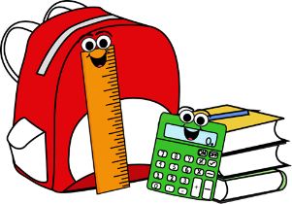
School Days
Discuss with 4 people!

