Presenting Findings Visually
Whatever you choose, text, table, or chart (or all three), your visual information should be self-explanatory. Any headings should be clear and informative. Any text accompanying a table or chart should reference the key points you want to highlight, but the visual should be understood even if the text is not read.
Text | Tables | Chart
Use when your key findings include only a few data points. | Use when your key findings lie in structured numeric information (more than three or four numbers) | Use when your key points lie in the relationships between numbers -- demonstrating trends or making comparisons.

No matter which visual display you use for your data, keep these things in mind:
- Only include information pertinent to your key points. Too much extra data can be distracting.
- If you include very involved visuals, those that will require time and attention to wade through, use them as appendices, not in your summary.
- When formatting, whether decimal spaces or fonts and column widths, be consistent throughout.
- Only get as technical as your audience and your data demands. Beyond means and frequencies, are standard deviations, p-values, and t-values necessary to clearly make your key points?
- Sort your data before finalizing any display. An unsorted table, chart, or graph is not self-explanatory. With sorting comes enlightenment.
- As much as possible, group your information so there are less data points to wade through. Grouping leads to clarity.
- Graphs, charts, and tables should answer more questions than they pose.

More on Tables
Tables are very effective when used for reference purposes.
- Title your table in a meaningful way.
- Avoid abbreviations if possible.
- It will be more meaningful to your audience if you convert actual counts into percentages.
- If you have historical data, include columns for comparison.
- Your data should make sense: earliest years to later years, largest down to smallest amounts, highlight the most important points.

More on Charts and Graphs
A rule of thumb when working with visuals like charts and graphs:
Just because you can, doesn’t mean you should.
The point of your reporting is to communicate important information in a way that is as accessible as possible. Sometimes “cooler” doesn’t mean “clearer communication.” For example, three dimensional charts and graphs are more difficult to take in visually. There is more for the viewer to mentally process in order to understand the data.
Not like this... | But like this
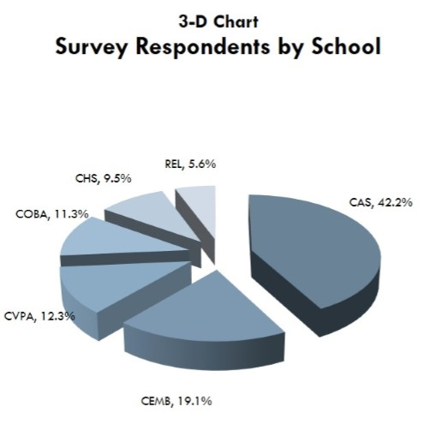 | 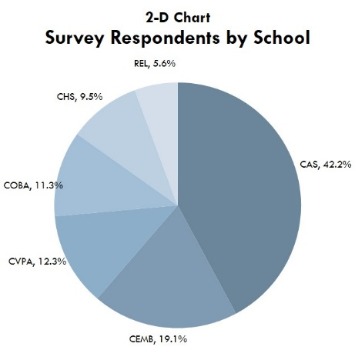

Pie Charts
Pie Charts work best for general findings (rather than nuanced differences) and are best understood with no more than five or six slices. They can only be used to show parts of a whole (if all parts total 100%).
- As with other graphics, remember to sort your data before finalizing and stay away from 3-D formats.
- Dark to light hues of the same color communicate more clearly than a variety of colors.
- Always include labels or a legend as well as percentages for each slice.

Not like this... | But like this
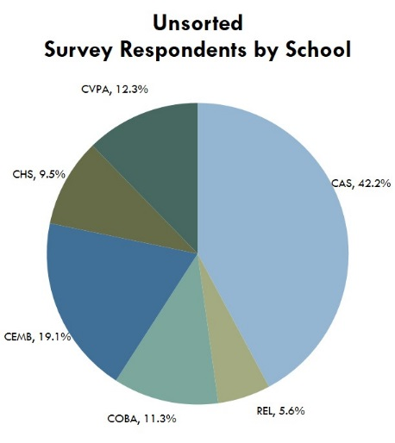 | 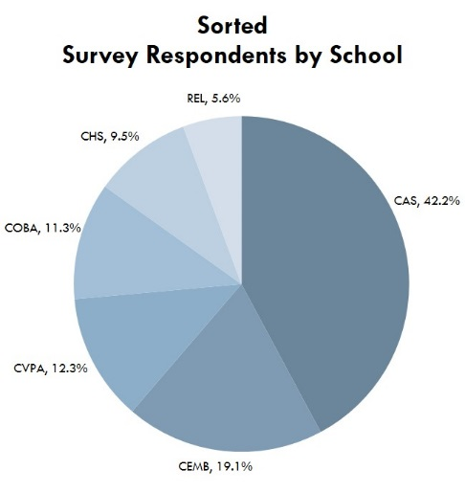

Bar Graphs
Bar graphs are often more effective than pie charts, particularly for comparing data directly.

It takes two pie charts to compare two years of data.
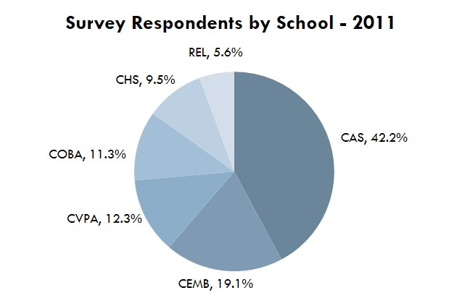 | 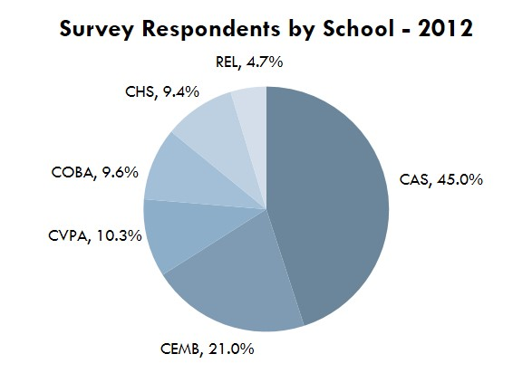

The same comparison can be shown in one bar graph
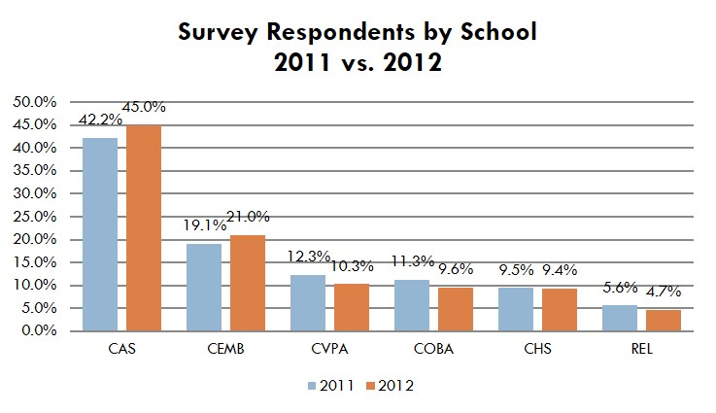
When working with bar graphs, keep the following in mind:
- As with other graphics, remember to sort your data before finalizing and stay away from 3-D formats.
Not like this... | But like this
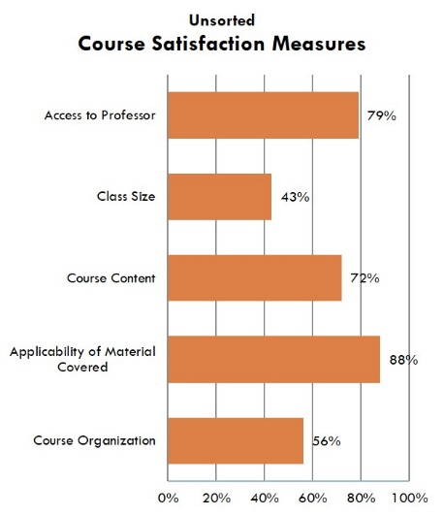 | 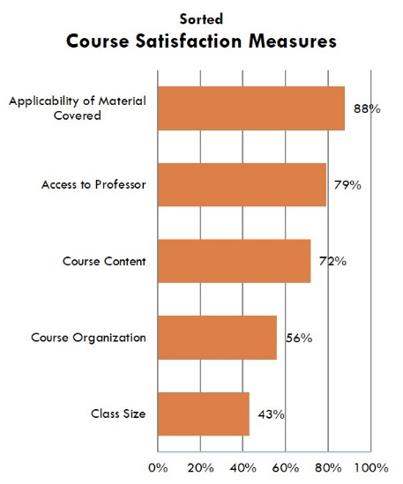
- If you are reporting on several different series of data, clustered bar graphs are often clearer than stacked bar graphs.

Not like this... | But like this
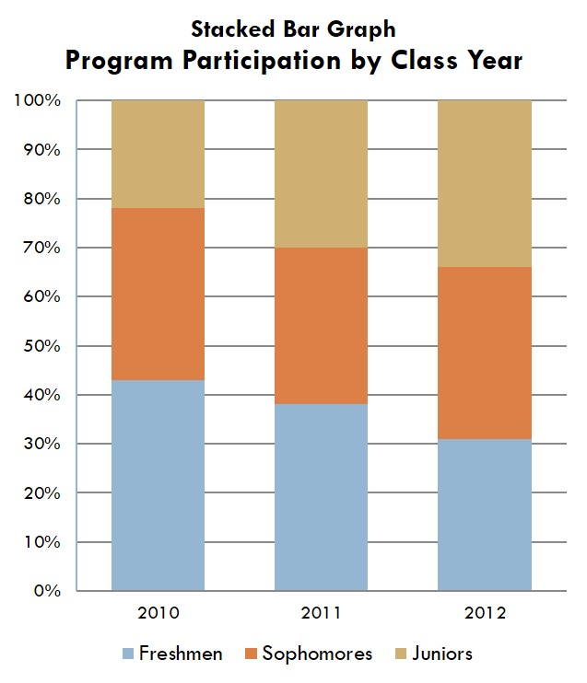 | 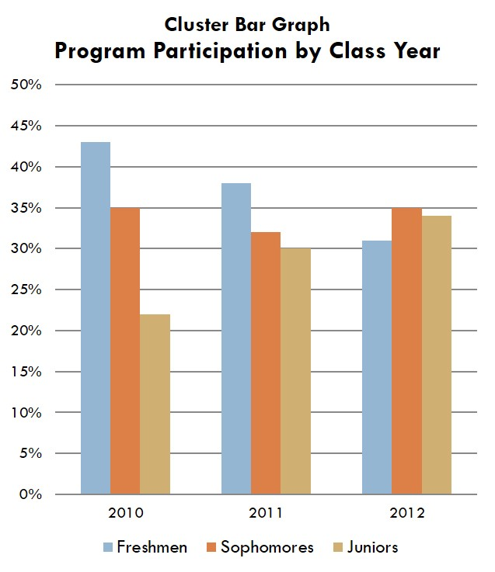

Line Graphs
Line graphs are most effective in presenting five or more data points over a period of time.
- As with other graphics, remember to sort your data before finalizing and stay away from 3-D formats.
- Typically, the horizontal axis (x-axis) denotes time and the vertical axis (y-axis) denotes the frequencies of what is measured.
- If more than one line appears on your graph, differentiate the lines by style, color, or plotting symbols.
- More than five (and sometimes even four) lines can lead to confusion, working against the clarity you are trying to achieve by using the graph. When possible, group for clarity.

Not like this... | But like this
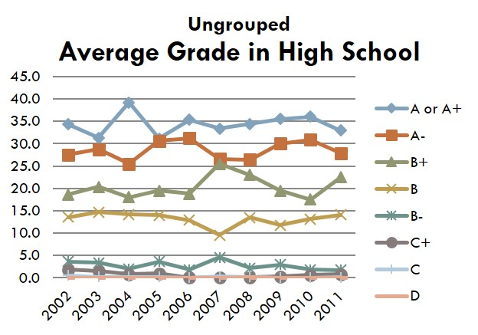 | 