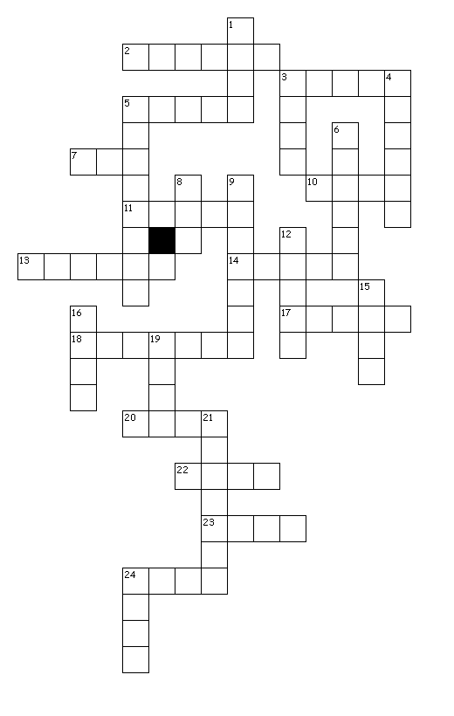

Past Participles

Down

1. see

3. feel

4. drive

5. finish

6. speak

8. feed

9. study

12. take

15. go

16. swim

19. come

21. think

24. sing

Across

2. play

3. fix

5. fly

7. run

10. ride

11. sleep

13. break

14. draw

17. eat

18. watch

20. leave

22. do

23. go

24. send