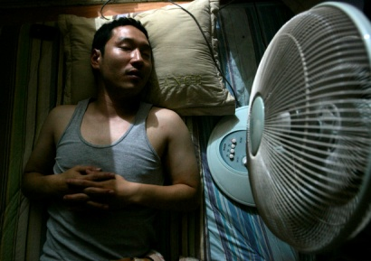
The Fan Death

There is a superstition in Korea that if you sleep with a running electric fan in a room with closed windows, you will die. Many believe that it will cause hypothermia, and asphyxiation
Oddly, there are no verified cases of this alleged phenomenon.
Reports of fan death first appeared in the 1970s. There is a conspiracy theory that the South Korean government created or perpetuated the myth as propaganda to curb the energy consumption of South Korean households during the 1970s energy crisis.
The Korea Consumer Protection Board (KCPB), a South Korean government-funded public agency, issued a safety alert in 2006 warning that "asphyxiation from electric fans and air conditioners" was among South Korea's five most common summer accidents or injuries, according to data they collected The KCPB published the following:

If bodies are exposed to electric fans or air conditioners for too long, it causes bodies to lose water and causes hypothermia. If directly in contact with air current from a fan, this could lead to death from an increase of carbon dioxide saturation concentration and decrease of oxygen concentration. The risks are higher for the elderly and patients with respiratory problems. From 2003 to 2005, a total of 20 cases were reported involving asphyxiations caused by leaving electric fans and air conditioners on while sleeping. To prevent asphyxiation, timers should be set, wind direction should be rotated, and doors should be left open.
In summer, mainstream South Korean news sources regularly report alleged cases of fan death. A typical example is this excerpt from the July 4, 2011, edition of The Korea Herald, an English-language newspaper:

A man reportedly died on Monday morning after sleeping with an electric fan running. The 59 years-old victim, only known by his surname Min, was found dead with the fan fixed directly at him.

This article also noted there was "no evidence" the fan caused the death, however.
Gord Giesbrecht, a professor of thermophysiology at the University of Manitoba, is a leading expert on hypothermia:
It's hard to imagine death by fan because to die of hypothermia, one's body temperature would have to get down to 28°C, drop by 10 degrees [Celsius] overnight.
Dr. Lee Yoon-song is a professor at Seoul National University's medical school and works with the school's Institute of Scientific Investigation. He has conducted autopsies on some of the people who have been described in Korean media as having succumbed to fan death and said,
When someone's body temperature drops below 35 degrees, they do start to lose judgment ability. So if someone was hiking and later found dead, that could be part of the reason. But we can't really apply this to fan accidents. I found most of the victims already had some sort of disease like heart problems or serious alcoholism. So hypothermia is not the main reason for death, but it may contribute.

He blames the South Korean media for the perpetuation of this myth.

Korean reporters are constantly writing inaccurate articles about death by fan, describing these deaths as being caused by the fan. That's why it seems that fan deaths only happen in Korea, when in reality these types of deaths are quite rare. They should have reported the victim's original defects, such as heart or lung disease, which are the main cause of death in these cases.

Ken Jennings, writing for Slate, says that based on "a recent email survey of contacts in Korea", opinion seems to be shifting among younger Koreans: "A decade of Internet skepticism seems to have accomplished what the preceding 75 years could not: convinced a nation that Korean fan death is probably not real." So what do you think, is fan death real or not?
Sources
Herskovitz, Jon. "Electric Fans and South Koreans: A Deadly Mix?" Reuters. 9 July 2007.
Hodges, Horace Jeffery. "Demystifying Fan Death."The Korea Herald. 30 January 2008.
Kenter, Peter. "South Korean Motorists Guard Against the Possibility of Fan Death." National Post 18 July 2008
Piercy, Justin. "Urban Legend: That Fan Could Be the Death of You." Toronto Star. 19 August 2008
Williamson, Steven. "A Fan-tastic Way to Die." [Rutgers] Daily Targum. 6 September 2007.
Yoon-seung, Kang. "Summer Death Revives Fan Death Myth." Korea Herald. 4 July 2011.

