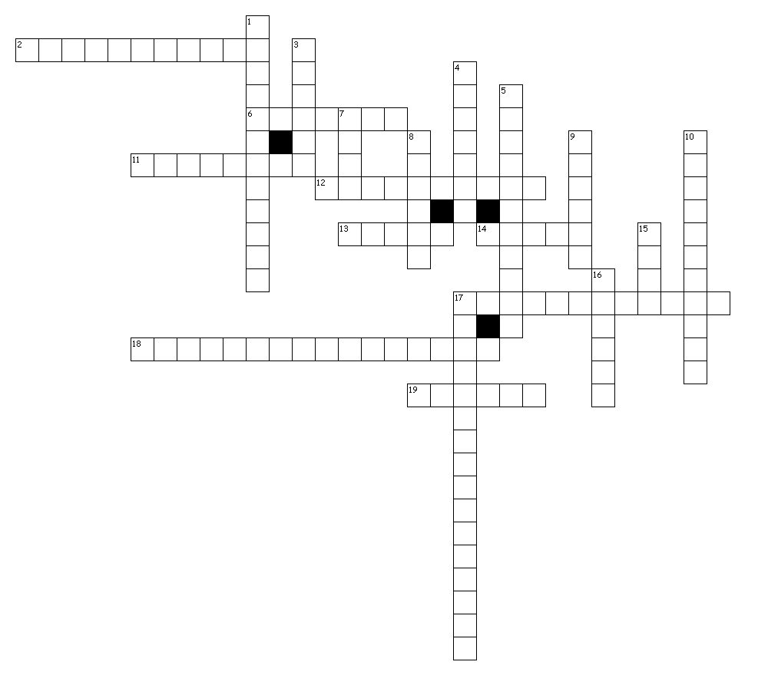

Hint:

mother

father

children

uncle

grandparents

grandfather

family

grandmother

nephew

niece

aunt

brotherinlaw

sisterinlaw

stepmother

husband

wife

cousin

parents

greatgrandmother

greatgrandfather

Across

2. mom or dad's mom

6. married man

11. plural of child

12. dad's wife (not your biological mother)

13. mother or father's brother

14. brother or sister's daughter

17. mom or dad's mom and dad

18. grandmother or granfather's mother

19. female parent

Down

1. sister's husband

3. aunt and uncle's child

4. your mother and father

5. brother's wife

7. mother or father's sister

8. a group of relatives

9. brother or sister's son

10. mom or dad's dad

15. married woman

16. male parent

17. grandmother or grandfather's father