Names
How much do you feel that you care about the environment (1-10)?
Do you think that the earth is in danger? Why or why not?
How much do you think about your impact on the environment? (1-10)
Do you let the water run when brushing your teeth?
Do you ever pick up trash that you see lying on the ground?
Do you use plastic bags?
Do you leave the lights on?
Do you waste paper?
Do you care about how much packaging is used when buying products, and how much waste you produce?
What is more important for you, your own comfort or the environment? Why?
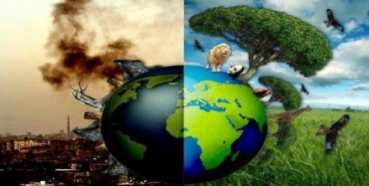
The Environment
Interview 3 people

