Questions | Name | Name | Name | Name
Have you ever had anything stolen from you? Explain.
Has anyone you know ever had anything stolen from them? Explain.
Are you ever worried about someone breaking in to where you live? Why or why not?
How do you protect your home from being broken into?
What do you do to protect yourself from being robbed or attacked when you are outside of your home?
Where do you feel the most scared of being attacked or robbed? Ex. Taxi, walking in a dark alley, travelling etc.

In your opinion, where is the most dangerous place in Korea for theft or assault? Why?
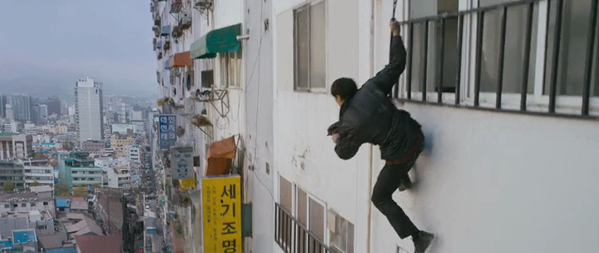
Crime
Survey 4 people!

