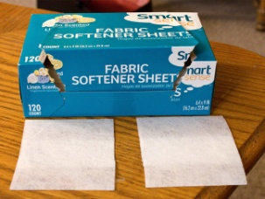
Dryer Sheets
These little pieces of cloth are pure magic, even after they've been used in the dryer! A used dryer sheet can buff out water spots from your mirrors and bathroom/kitchen fixtures, tackle waterspots on your shower doors, and even get rid of that disgusting ring in the toilet bowl! Use new dryer sheets to wipe your cupboards, and you'll be not only be cleaning them but adding a dust-fighting layer to them as you go!
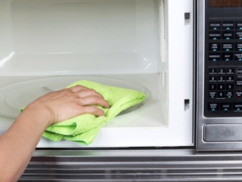
Microwave and Vinegar
Make the inside of your microwave sparkle by nuking some vinegar for a few minutes! Place equal amounts of vinegar and water in a microwave safe bowl and place it in the microwave. You'll also want to add a small wooden object (i.e. a chopstick, toothpick, wooden spoon) to your bowl to prevent any boiling or explosion dangers. Then set your microwave for 5-10 minutes (max out the time if you've got serious grime to deal with!) and enjoy the steam cleaning. Wait a couple minutes to open it up, then wipe the surfaces clean with a sponge or paper towel! Now wasn't that easy?
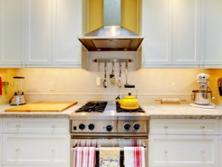
Clean with Oil
An oil spattered kitchen is just the worst to clean, because try as you may, the soap just never seems to be enough to clean it! So instead, use oil to pick your oil up! Add a few drops of vegetable oil to paper towel, then wipe the greasy surface and watch the oil disappear! When you're done, simply wipe it with a clean towel and stand back to admire your shiny surfaces!
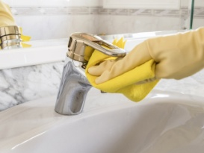
Hard Water Stains and Vinegar
Hard water stains can be both an eye-sore and nightmare to get rid of! Approach them in the future by being super lazy, and watch them disappear! Just soak a few paper towels in white vinegar, then place them on the hard water stains in question: on your faucets, your bath tub, or the drip pan for your refrigerator's water dispenser! Come back an hour later and wipe clean with a towel, and witness the sparkle!

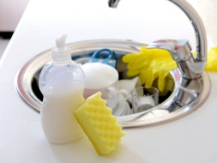
Sanitize Sponges in the Microwave
Next time you're worried about spreading germs in your kitchen or bathroom, just throw your sponges in the microwave! Make sure they're wet, then toss them in (preferably on a microwave safe surface), and turn the microwave on high for 2 minutes. You'll be eliminating 99% of all the little microbes that might be living in there (don't trust me -- the Journal of Environmental Health discovered this fact!) instead of spreading germs while you clean!

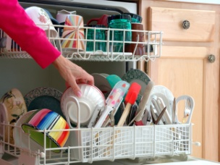
Clean a Dishwasher
We don't often think about cleaning the appliances that clean everything else, like your dishwasher, but it needs to be done! Place a container filled with white vinegar in the top rack of your dishwasher and run it on its hottest cycle with nothing else inside. Then, sprinkle some baking soda along the floor of the dishwasher, and run it again on a short-hot cycle, and you'll have a super clean dish washing machine!

