What I Did Last Saturday

Directions: Recall and list everything you did last Saturday in the left-hand column. In the right-hand column (using the list in Appendix 4), list all the activities you would need to accomplish if you were a parent of a newborn baby.

Things I Did Last Saturday |  | Things I Would Need to Do if I Had a Baby
 | 1:00 a.m.
 | 2:00 a.m.
 | 3:00 a.m.
 | 4:00 a.m.
 | 5:00 a.m.
 | 6:00 a.m.
 | 7:00 a.m.
 | 8:00 a.m.
 | 9:00 a.m.
 | 10:00 a.m.
 | 11:00 a.m.
 | 12:00 noon
 | 1:00 p.m.
 | 2:00 p.m.
 | 3:00 p.m.
 | 4:00 p.m.
 | 5:00 p.m.
 | 6:00 p.m.
 | 7:00 p.m.
 | 8:00 p.m.
 | 9:00 p.m.
 | 10:00 p.m.
 | 11:00 p.m.
 | 12:00 midnight

Things I Would Have to Do if  I Had a Baby | Amount of Time It Would Take
Feed baby every 2-3 hours | 25 minutes, at least 8 times a day
Make baby’s formula | 20 minutes per day
Change diapers every time the baby is fed and when needed | 5-10 minutes, 8-10 times per day
Give the baby a bath | 30 minutes each day
Do the baby’s laundry | 45 minutes each day
Play with baby | 30 minutes, 5 times a day
Change the babies clothes | 10 minutes 2-3 times a day
Put the baby to bed | nap time 40 minutes, bedtime 1 hour each day
Pack the babies things | 20 minutes each time you want to go out
Attend to crying baby | 15 minutes 12 times a day

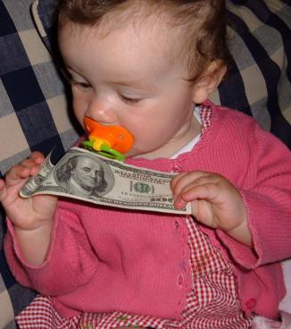
Show Me…. The Money!
You just found out that you are going to be a parent in one month!
Before you begin your “shopping” for this child, guess how much money you will need to raise your baby in a healthy environment for ONE YEAR!

My Estimate:

Directions: Using the resources provided, research the cost of the following items needed to provide
for a baby. Estimate the amount of each item that would be needed for a 12-month period.
Continuing Expenses | Cost | One-Time Expenses | Cost
Doctor Visits / Shots |  | Soothers
Formula x 12 |  | Crib
Bottles / Nipples |  | Mattress
Baby Food x 12 |  | Sheets / Blankets
Wet wipes |  | Mattress Cover
Toys |  | Play mat
Diapers x 12 |  | Stroller
Medicine |  | Thermometer
Child Care Costs x 12 |  | Mobile
Transportation to child care |  | Diaper Bag
Baby Clothes (t-shirts, sleepers, outfits, coats, hat, socks, shoes)  3 months 6 months  9 months 12 months |  | Infant bathtub
 |  | Washcloths, towels, hairbrush
 |  | Car Seat
 |  | High Chair
Other: |  | Dresser
 |  | Other:

Total Costs for One Year:

