Questions | Name | Name | Name | Name
Have you ever called 119? Why?
Has anyone you know had to call 119? Why?
Have you ever experienced seeing other people in an emergency? What did you do?
Do you know any first aid?
If you were in an emergency in another country do you feel confident enough in English to call 911?
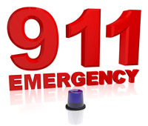
Someone call 911
Survey 4 people!

