7 Reasons to Drop Social Media Friends
by Amanda Morin 5/23/15

1. Swearing Too Much
Using profanity in social media indicates immaturity and lack of class. Basically swearing to much online makes you look like an idiot!

2. Trolls
These people are the ones who always have to compete with your statuses or say something negative.

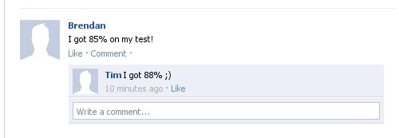

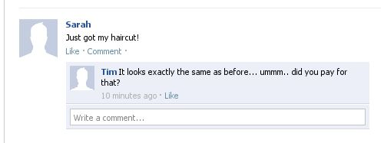

3. Attention Seekers

4. Oversharing

People don't need to know every detail of your life, It is actually annoying!

5. Complaining a Lot

6. Posting Vague Comments
This is one thing I absolutely won't tolerate from my Facebook friends. I'm of the opinion that if you have something to say, just say it.

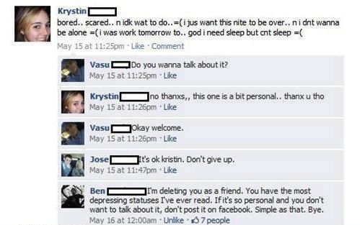

7. Using Facebook to Fight With People
People having personal fights on social media is idiotic! Nobody wants to hear about the fight your having, settle it in private!

